**Visualization 1: Milk used in the production of milk products (2011-22) in the UK**

Line Graph:

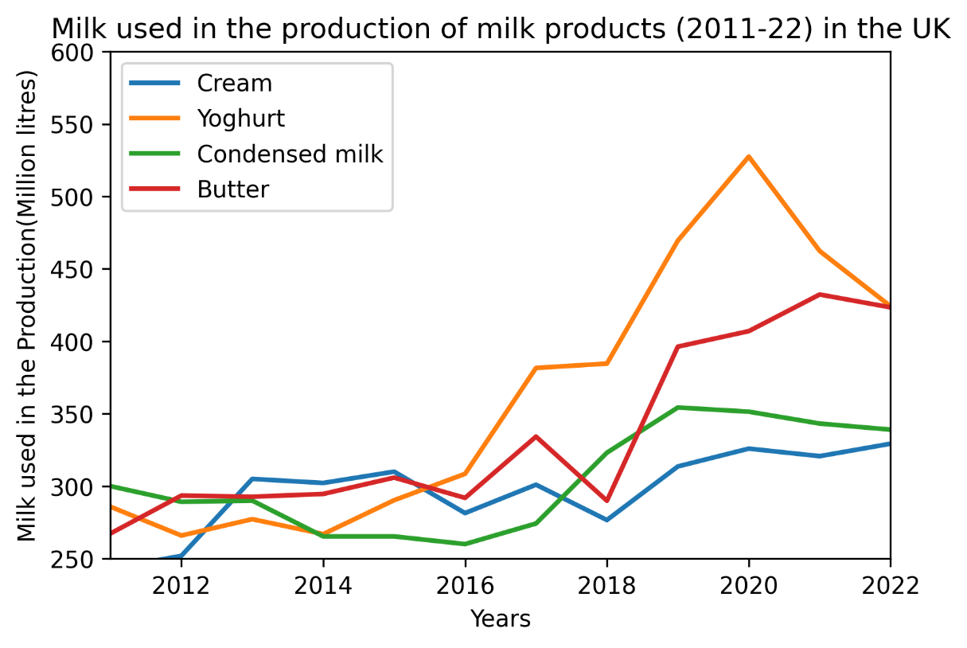

The Line Graph depicts the volume of milk used by dairies to produce milk products such as cream, yoghurt, condensed milk, and butter from 2011 to 2022. I picked a line graph because the difference in milk used to produce a milk product over the last ten years is easily visible and understandable. In 2022, the majority of milk is used to make yogurt and butter, whereas, in 2011, the majority of milk was used to make condensed milk.

**Visualization 2: Tokyo 2020 Olympics Medal Count**

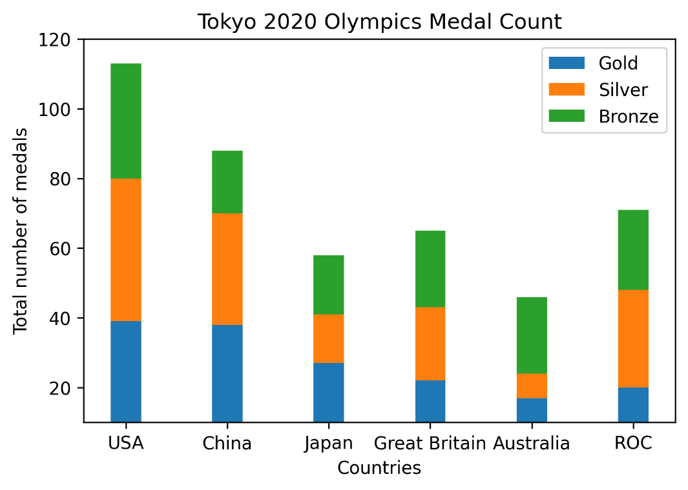

A stacked bar plot is a helpful tool for figuring out how many medals the top six countries will collectively win in 2020. The stacked bar plot makes it simple to examine how many of each type of medal each country has won as well as the different types of medals they have won. The United States, China, and the Russian Olympic Committee all earned the most medals in Tokyo 2020 Olympics.

**Visualization 3: Revenue of the companies in millions of dollars**

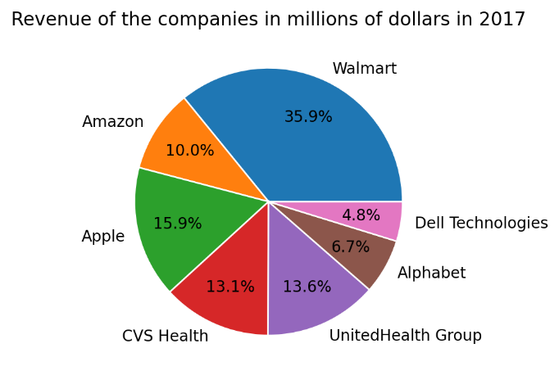 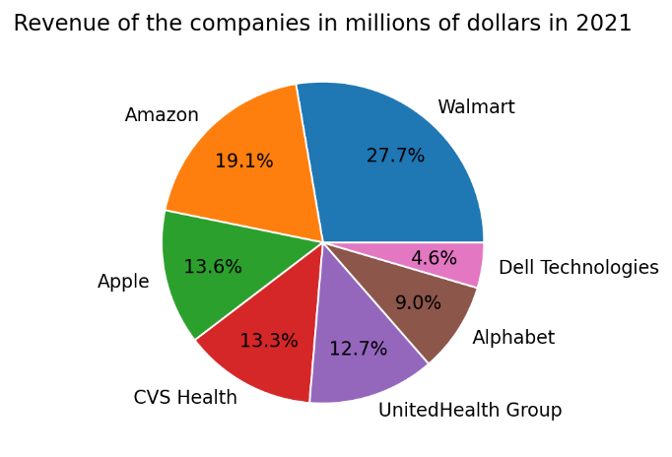

The pie chart is the best graph for comparing company revenue in two different years. The given pie chart compares the revenue of Walmart, Amazon, Apple, CVS Health, UnitedHealth Group, Alphabet, and Dell Technologies in the years 2017 and 2021.

GitHub repo Link:

Data source link:

1. <https://www.gov.uk/government/statistics/milk-utilisation-by-dairies-in-england-and-wales>
2. <https://www.kaggle.com/datasets/adityakocherlakota/fortune500-2017-2021>
3. <https://www.kaggle.com/datasets/jamieeeee/tokyo-2020-olympics-medal-count>